**CSE 4262 Data Analytics Lab**

**Lab 3: Machine Learning with Spark**

Outcomes: Aer this lab students will be able to:

• Apply PySpark MLib libraries to the development of machine learning applications. • Understand ML Pipeline concepts and use them to build machine learning algorithms and applications.

**Machine Learning Pipeline – a quick introduction**

One of the major a$rac ons of Spark is its ability to scale computa ons massively, and this is exactly what you need for machine learning algorithms. However, the caveat is that all machine learning algorithms cannot be effectively parallelized. Each algorithm has its challenges for parallelization, whether task or data parallelism. Spark is becoming the de-facto pla,orm for building machine learning algorithms and applica ons. This lab will first cover machine learning interfaces and organiza on, including the new ml pipeline, which has become mainstream in 2.0.0. Then, we will delve into the following machine-learning algorithms:

• Basic sta s cs

• Linear regression

• Classifica on

• Clustering

• Recommendation

ML pipelines were developed to address the fact that machine learning is not just a bunch of algorithms, such as classification and regression, but a pipeline of ac ons performed over a Dataset. Let's take a quick look at the tasks involved in a typical machine-learning process. The following figures show the top-level ac vi es of Spark ML libraries(mlib) and their API organiza on.

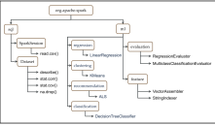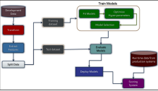The newer API has introduced a very powerful concept of pipelines where different stages of machine learning work can be grouped as a single entry and can be considered as one seamless machine learning workflow. A pipeline contains a set of stages where each stage is either a Transformer or an Estimator. All of these stages run in sequence and the input dataframe gets transformed while it passes through each stage.

**Transformer:** A Transformer is a high-level abstraction of feature transformer and learned models (models returned by Estimators). This component either adds, deletes, or updates exis ng features in the dataframe. **Each transformer has a transform () method which gets called when the pipeline is executed.** For example, **VectorAssembler is a transformer** as it takes the input dataframe and returns the transformed dataframe with a new column which is a vector representation of all the features.



**Estimator:** An Estimator is a high-level abstraction of a learning algorithm that returns a Model (a Transformer) and the returned model transforms the dataframe by the parameters which are learned during the fi<ng/learning phase. **Each estimator has a fit() method** which returns a Model which in turn has a transform() method. For example, **Logistic Regression is an estimator** that returns a LogisticRegresionModel (a Transformer) aer learning parameters about the data.

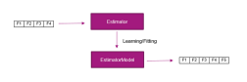

**Write down the difference between a Transformer and an Estimator**

1. **Transformer** modifies or updates features in a DataFrame using the transform() method. Example: VectorAssembler combines multiple columns into a single vector column. While **Estimator** trains on data to learn parameters and produces a Model (which is a Transformer) using the fit() method. Example: LogisticRegression fits on data and returns a LogisticRegressionModel.
2. **Transformer** directly transforms the DataFrame by adding, deleting, or updating features. But the **Estimator** returns a model (Transformer) after the training phase, which then transforms the DataFrame based on learned parameters.

Spark provides a class that forms by combining different PipelineStages (Estimator and Transformers) which run in sequential order. Pipeline class has a fit () method which kicks off the entire workflow. This execution returns a PipelineModel which has the same number of stages as the pipeline except that all

the Estimator stages are replaced by their respective Model (a Transformer) which were fitted during the execution. During execution, each stage is called sequentially, and based on the type of PipelineStage (whether it's a Transformer or an Estimator) their respective fit () or transform() methods are called.

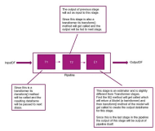

**Task1. Apply some basic transformers and estimators to formulate an ML pipeline** a) Download a file Social_Network_Ads.csv from the following link: h$ps://github.com/kaysush/spark-ml-pipeline-demo/blob/master/Social_Network_Ads.csv and upload it to your workplace at Google-collab.

b) Read the file using the following command:

df = spark.read.csv('/content/Social_Network_Ads.csv',header=True,escape="\"") c) Check the datatypes of the column headers.

d) Change the type of the a$ributes including Age, Es matedSalary and purchased from string to double or integer using the following commands

from pyspark.sql.types import IntegerType,BooleanType,DateType, DoubleType df=df.withColumn("Age",df.Age.cast(IntegerType()))

…

**e) Split the data using randomSplit()method. Partition the data into Training for 80% and 20% for the Testing. Present the amount of testing and training data into the blank box.**

**Train: 325**

**Test: 75**

f) Since our dataset has a categorical column, Gender, we'll have to perform OneHotEncoding on it before passing it to LogisticRegression because machine learning algorithms do not support string values. Use the following commands to perform OneHotEncoding on the Gender attribute. These are the first and second Transformers for our pipeline.

from pyspark.ml.feature import StringIndexer

from pyspark.ml.feature import OneHotEncoder

genderIndexer=StringIndexer(inputCol="Gender", outputCol="GenderIndexed") genderOneHotEncoder=OneHotEncoder(inputCols=[genderIndexer.getOutputCol()],outp utCols=["GenderOHE"])

g) Vector Assembling the features is a necessary step before model training starts. The machine learning algorithms do not take a variable number of columns as input, rather they take a vector of features. This is the third Transformer for our pipeline.

from pyspark.ml.feature import VectorAssembler

vectorAssembler=VectorAssembler(inputCols=features, outputCol="features")

h) Though feature scaling is an op onal step it certainly helps in decreasing the convergence me. Hence, we have included that in our pipeline. This is the fourth Transformer for our pipeline. from pyspark.ml.feature import StandardScalerscaler =

StandardScaler(inputCol="features", outputCol="scaledFeatures", withStd=True, withMean=False)

i) Now we are going to apply our Es mator -Logis c Regression to learn from the data and later on predict the user buying behavior.

from pyspark.ml.classification import LogisticRegression

logistic_regression = LogisticRegression(featuresCol="scaledFeatures", labelCol=dependentVar)

j) Now that our components are ready to let’s put them in the pipeline and start the training of our models.

from pyspark.ml import Pipeline

pipeline=Pipeline(stages=[genderIndexer,genderOneHotEncoder,vectorAssembler,sca ler,logistic_regression])

model=pipeline.fit(train)

k) The fit () method of the pipeline returns a PipelineModel object which we’ll use to predict the behavior of unknown customers

results=model.transform(test)

l) To gauge the accuracy of our model we’ll use Spark’s built in BinaryClassifica onEvaluator class. from pyspark.ml.evaluation import BinaryClassificationEvaluator

evaluator=BinaryClassificationEvaluator(labelCol=dependentVar)

accuracy = evaluator.evaluate(results)

print (f"Accuracy of the Model: {accuracy}")

**Present the Model accuracy in the blank box:**

**Accuracy of the Model:** 0.9228611500701263

**m) Now explain your understanding of ML Pipeline in the following box**

A Machine Learning Pipeline in PySpark automates machine learning workflows by organizing data processing steps into a sequence of Transformers and Estimators. Transformers (VectorAssembler) modify features, while Estimators (LogisticRegression) train on data to produce models. Each stage's output feeds into the next, streamlining the process from data preprocessing to model prediction. It enhances reproducibility, scalability, and experimentation efficiency.

**Task2. Understand the implementaon** of Mul layerPerceptronClassifier and LinearSVC for classifica on

a) Download a file Social_Network_Ads.csv from the following link: h$ps://github.com/davutemrah/spark_repo/blob/master/data/diabetes.csv and upload it to your workplace at Google-collab.

b) Split the data into 60% for training and 40% for tes ng.

c) Use Mul layerPerceptronClassifier() from pyspark.ml.classifica on package and LinearSVC() from pyspark.ml.classifica on package.

d) Evaluate their performance using Mul classClassifica onEvaluator from pyspark.ml.evalua on package.

e) Attached the pyspark program below.

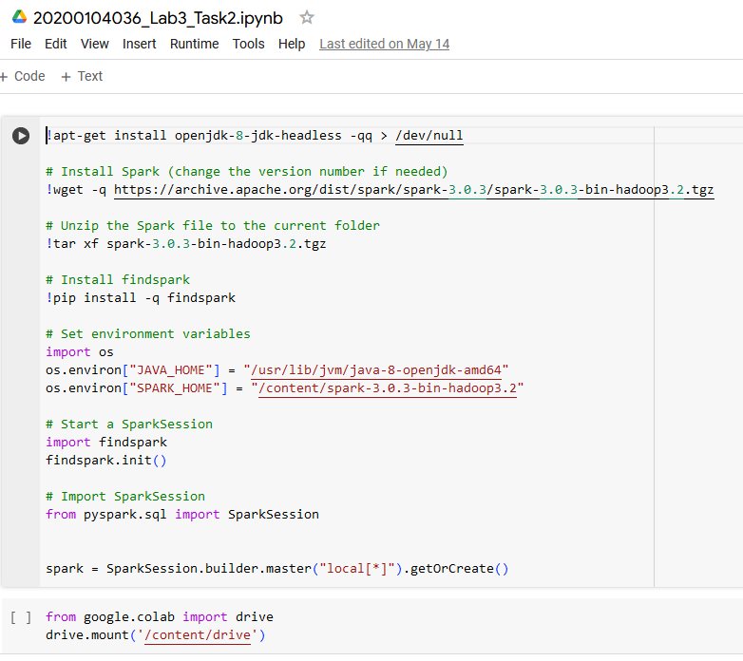

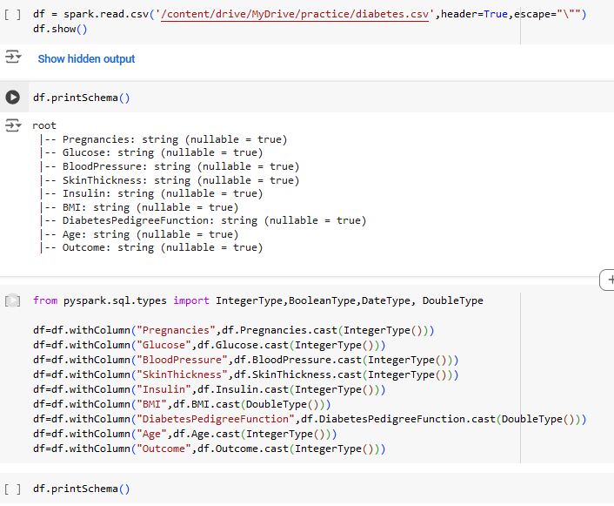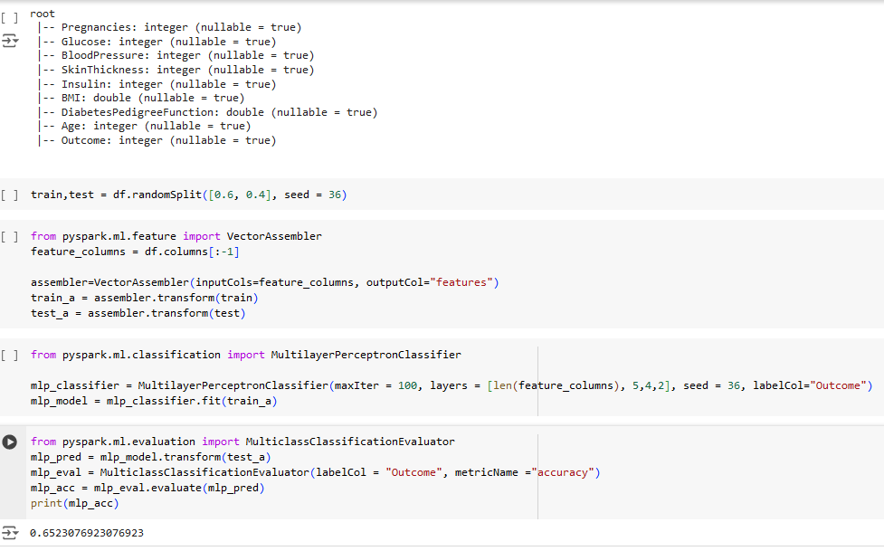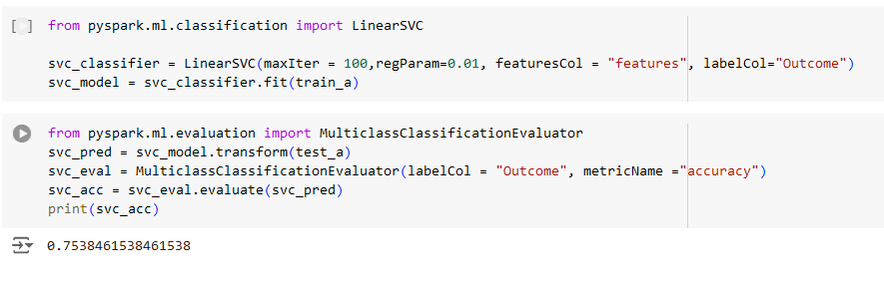

**Task3:**

Recommenda on systems are one of the most visible and popular machine learning applica ons on the Web, from Amazon to LinkedIn to Walmart. The algorithms behind recommenda on systems are very interes ng. Recommenda on algorithms fall into roughly five general mechanisms: knowledge-based, demographic-based, content-based, collabora ve filtering (item-based or user-based), and latent factor

based. Of these, collabora ve filtering is the most widely used and unfortunately very computa onally intensive. Spark implements a scalable varia on, the Alterna ng Least Square (ALS) algorithm authored by Yehuda Koren, available at h$p://dl.acm.org/cita on.cfm?id=1608614. It is a user-based collabora ve filtering mechanism that uses the latent factors method of learning, which can scale to a large Dataset.

a) Download a file ra ng.csv from the Google classroom and upload it to your workplace at Google collab.

b) Change the type of the a$ributes including userId, movieId, and rating from string to double or integer.

c) Split the data using randomSplit()method. Partition the data into Training for 70% and 30% for the Testing.

d) Use the following code to ini alize the ALS() model from pyspark.ml.recommendation import ALS package.

from pyspark.ml.recommendation import ALS

# Create an ALS instance

algALS = ALS()

# Set parameters for ALS model

algALS.setItemCol("movieId") # Set the name of the column for items (products) algALS.setUserCol("userId")

algALS.setRank(12)

algALS.setRegParam(0.1) # Regularization parameter (equivalent to lambda in MLlib)

algALS.setMaxIter(20)

e) Call the fit () method of the algALS object with the train data. Thereafter, call the transform() method with test data to make the prediction.

f) Filter out rows from prediction with null values before the evaluation.

g) Evaluate their performance using RegressionEvaluator() from pyspark.ml.evaluation import RegressionEvaluator package.

h) A$ached the pyspark program below.

**Python Code:**

import pandas as pd

from pyspark.sql import SparkSession

from pyspark.sql.types import IntegerType, DoubleType

# Initialize Spark session

spark = SparkSession.builder.appName("ALSExample").getOrCreate()

# Load the data

file_path = "/rating.csv"

ratings_df = spark.read.csv(file_path, header=True, inferSchema=True)

# Convert the data types of userId, movieId, and rating

ratings_df = ratings_df.withColumn("userId", ratings_df["userId"].cast(IntegerType())) \

.withColumn("movieId", ratings_df["movieId"].cast(IntegerType())) \

.withColumn("rating", ratings_df["rating"].cast(DoubleType()))

# Step c: Split the data into training and testing sets

train_data, test_data = ratings_df.randomSplit([0.7, 0.3])

# Step d: Import ALS package and initialize ALS model

from pyspark.ml.recommendation import ALS

# Create an ALS instance and set parameters

als = ALS(userCol="userId", itemCol="movieId", ratingCol="rating", rank=12, regParam=0.1, maxIter=20)

# Step e: Fit the ALS model on the training data and make predictions on the test data

model = als.fit(train_data)

predictions = model.transform(test_data)

# Step f: Filter out rows with null values in predictions

predictions = predictions.filter(predictions.prediction.isNotNull())

# Step g: Evaluate the model performance using RegressionEvaluator

from pyspark.ml.evaluation import RegressionEvaluator

# Initialize the evaluator and evaluate the model

evaluator = RegressionEvaluator(metricName="rmse", labelCol="rating", predictionCol="prediction")

rmse = evaluator.evaluate(predictions)

print(f"Root Mean Squared Error (RMSE) on test data = {rmse}")

# Stop the Spark session

spark.stop()

**Assignment 3**

Choose a suitable dataset containing various a$ributes. The dataset should have at least 10,000 samples. Your task is to perform data clustering to uncover inherent structures or pa$erns within the dataset. Specifically, you are required to:

1. Preprocess the dataset: Handle missing values, scale features, and any other necessary preprocessing steps.

2. Apply at least two different clustering algorithms: You can choose from a variety of clustering algorithms such as K-means, hierarchical clustering, DBSCAN, Gaussian Mixture Models (GMM), etc.

3. Evaluate the performance of each clustering algorithm: Use appropriate metrics to evaluate the quality of the clusters generated by each algorithm. Some common evalua on metrics include silhoue$e score, Davies-Bouldin index, and Calinski-Harabasz index.

4. Interpret the results: Analyze the clusters obtained from each algorithm and provide insights into the characteris cs of each cluster. What do these clusters represent? Are there any no ceable pa$erns or trends?

5. Compare the performance of the clustering algorithms: Discuss the strengths and weaknesses of each algorithm based on their performance on the given dataset.

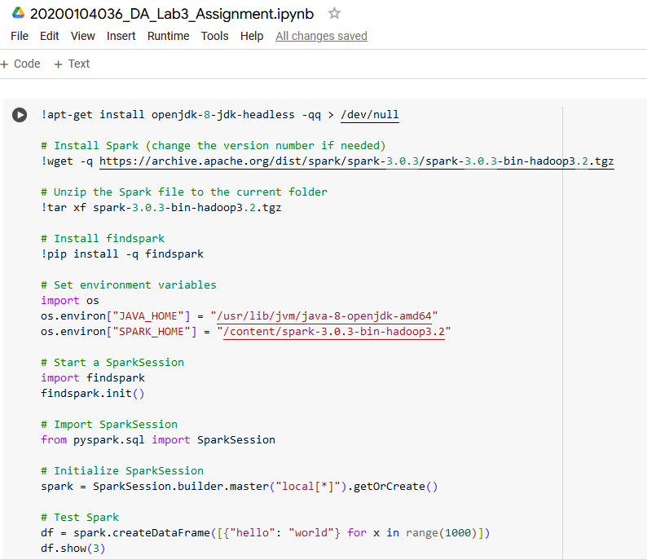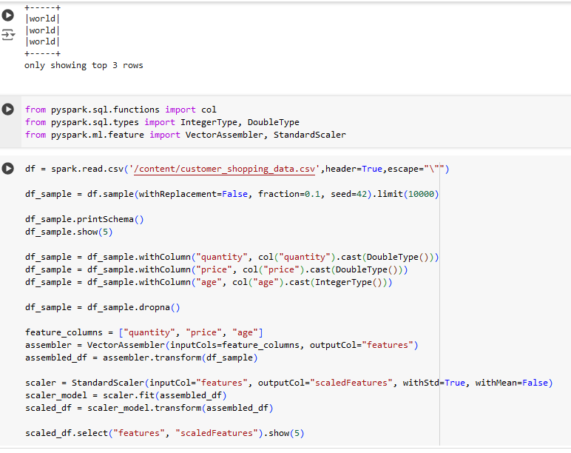

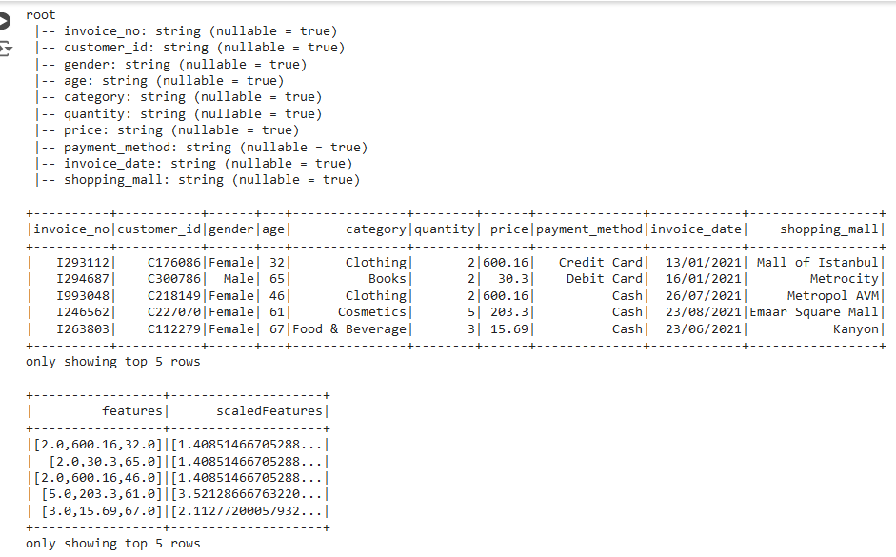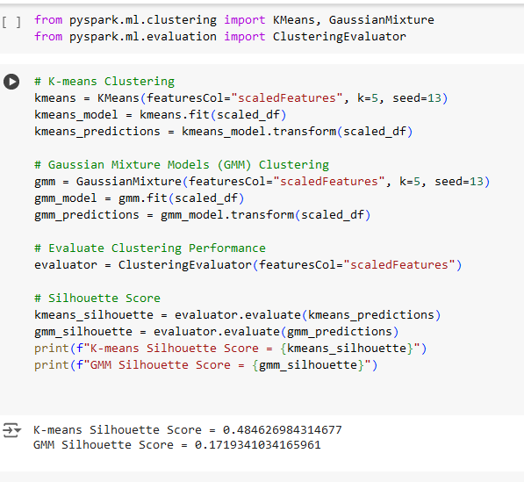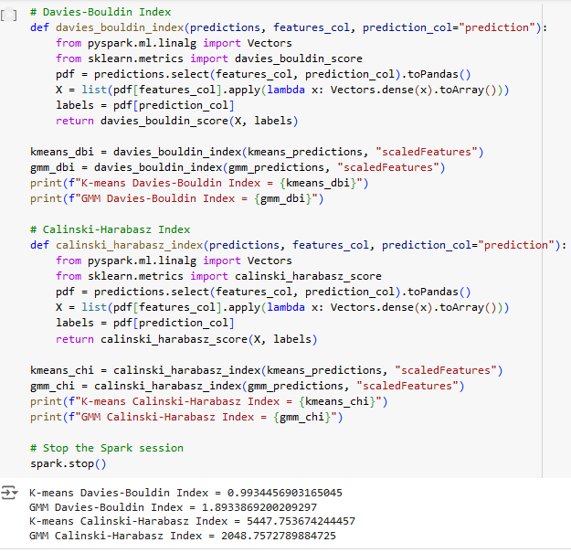

4. **K-means clustering** segmented customer data into five clusters based on purchasing behavior and demographics. Cluster 0 includes moderate spenders with an average of 2.5 items per purchase, spending $150, and aged 35. Cluster 1 represents high-value customers purchasing 3 items, spending $2000, and aged 45. Cluster 2 consists of younger, budget-conscious customers buying 1 item, spending $50, and aged 25. Cluster 3 includes top spenders purchasing 5 items, spending $3000, and aged 50. Cluster 4 represents moderately high-value customers buying 4 items, spending $1000, and aged 30.

**Gaussian Mixture Models (GMM)** also segmented the data into five clusters with a more nuanced approach. Cluster 0 includes moderate spenders buying 2 items, spending $120, and aged 34. Cluster 1 represents high-value customers purchasing 3.5 items, spending $1800, and aged 44. Cluster 2 consists of younger, budget-conscious customers buying 1.2 items, spending $70, and aged 27. Cluster 3 includes affluent individuals buying 4.5 items, spending $2500, and aged 48. Cluster 4 represents younger professionals or families buying 3 items, spending $850, and aged 32.

Both K-means and GMM identified clusters of high spenders making large purchases, typically older or affluent customers. They also highlighted younger, low-spending customers, indicating budget-conscious buyers. Additionally, both algorithms identified clusters of moderate spenders, reflecting regular purchasing behavior without extreme values.

**5.** **K-means clustering** is a popular algorithm known for its simplicity, scalability, and interpretability. It is easy to implement and computationally efficient, making it well-suited for large datasets and high-dimensional data. The clear cluster assignments with well-defined centers add to its interpretability.

However, K-means assumes clusters are spherical and of similar size, which might not always be true. It is also sensitive to the initial placement of centroids, causing variability in results. Additionally, K-means struggles with clusters of varying shapes and densities, making it less effective for overlapping clusters.

On the other hand, **Gaussian Mixture Models (GMM)** clustering offers a more flexible and nuanced approach. GMM provides probabilistic assignments, assigning probabilities to data points for each cluster, which allows for soft clustering. It can model clusters of different shapes and sizes and handles overlapping clusters better, accommodating more complex data distributions.

Despite these advantages, GMM is more computationally intensive and complex compared to K-means. It also requires careful tuning of hyperparameters such as the number of components and convergence criteria to achieve optimal performance.